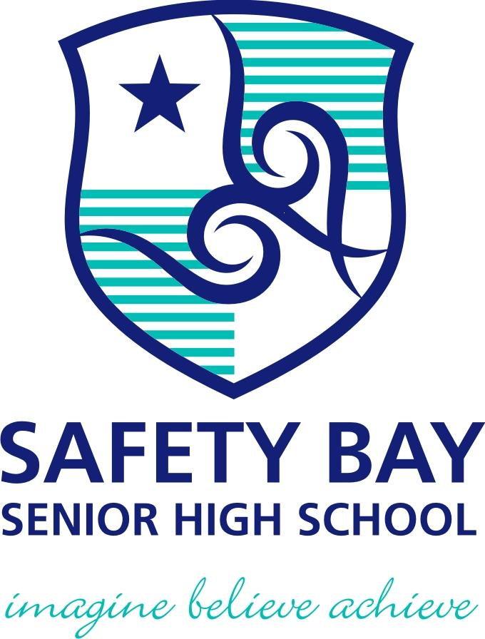

YEAR: 8
SUBJECT: SCIENCE

TEST: Physical and chemical change
TIME: 55 mins
QUESTIONS: Part A: Multiple Choice Questions (10 marks)
Part B: Short Answer Questions (35 marks)
Part C: Extended Answer (4 marks)
GIVEN MATERIAL: Ion sheet and periodic table
TOTAL MARKS: 46 marks

DO NOT WRITE ON OR MARK THIS PAPER
Part A: Multiple Choice Questions (1mark each)
Answer this section on the separate multiple – choice answer sheet

- Condensation is the name of the process of a gas changing into a liquid by cooling. Select the opposite process
    - Evaporation
    - Melting
    - Solidification
    - Sublimation

- Which of the following is a chemical change?
- Sawdust is produced from wood being cut by a power saw.
- Water freezes to form ice.
- Fireworks explode in a colourful light display.
- Juice is obtained from an orange.
- A permanent colour change may be an indication that a chemical reaction has taken place. Identify which of the following is NOT an indication of a chemical reaction.

- sugar caramelising
- toast bread
- a glass breaking
- burning a match

- The substances that you begin within a reaction is called as
- reactants.
- products.
- elements.
- compounds.

- Which of the following would NOT be a physical change?
- freezing water to make ice cubes
- melting gold to make jewellery
- burning gasoline in a lawnmower
- boiling water for soup
- The term corrosion means:
- coating iron with a material such as paint
- a chemical reaction where a metal reacts with oxygen
- a chemical reaction where oxygen is a product
- is coating iron with zinc metal

- The Law of Conservation of Mass states that ‘During a chemical reaction, atoms are neither created nor destroyed’. This law suggests that if a chemical reaction occurred inside a closed container, the total mass of the container and its contents would:

- increase as more chemicals are produced by the reaction.
- decrease if the chemical reaction produces a gas.
- stay the same.
- increase or decrease depending on the type of chemical reaction.

- Joe collected some snow and placed it in a beaker. During the day it melted to produce clear water. Joe and his friends made the following comments about the process.

State who you believe is correct.

- Joe: This is a chemical change as there is a change in colour.
- Jill: The beaker is now warmer than when you collected the snow. This must be a chemical change as energy is absorbed.
- Jenny: This is a physical change as the trapped air bubbles react with the snow.
- Jamal: This is a physical change as no new substances are created.

- Analyse the word equation:
methane + oxygen → carbon dioxide + water + energy
This reaction shows that:
- Oxygen is a product of this reaction.
- Methane is a product of this reaction.
- This is a physical change.
- Carbon dioxide is a product of this reaction.

- The recycling of aluminium can be considered a series of physical changes as shown by the flow diagram below.

Which stages of the aluminium recycling process would be considered a change of state?
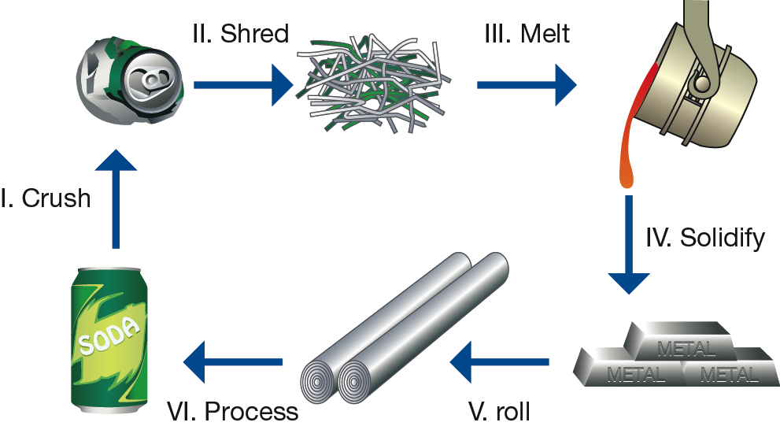
- I and II
- II and III
- III and IV
- only III

YEAR: 8
SUBJECT: SCIENCE
Name__________________________________________________
Form ____________

TEST: Physical and chemical change
TIME: 55 mins
QUESTIONS: Part A: Multiple Choice Questions (10 marks)
Part B: Short Answer Questions (32 marks)
Part C: Extended Answer Question (4 marks)
Other material: Periodic table and ion table
TOTAL MARKS: 46 marks
Part A: Multiple Choice Answers (1 mark each)
Put a cross (X) through the correct answer.

1 X b c d
2 a b X d
3 a b X d
4 X b c d
5 a b X d
6 a X c d
7 a b X d
8 a b c X
9 a b c X
10 a b X d

Marks

Part A: Part B: Part C:
Multiple Choice Short Answer Extended Response Total

/10
/20

/32

/46

/4

Part B: Short Answer Questions
11. Define the term precipitate (1 mark)
Solid forming during chemical reaction
12. Label each process as a physical or chemical change: (6 marks)
Slicing potatoes for fries | Physical
A nail rusting | Chemical
Baking cookies | Chemical
Butter melting | Physical
Food spoiling | Chemical
You cut your hair | Physical

13. Write word equations for the following chemical reactions. (2 marks)
a) Hydrogen gas and oxygen gas combine to form water.
Hydrogen + oxygen → water
b) Heating copper (II) carbonate forms copper (II) oxide and carbon dioxide.
Copper (II) carbonate → copper (II) oxide + carbon dioxide

b) Write the chemical equation for the following (2 marks)
i) Hydrogen gas and oxygen gas combine to form water.
H₂ + O₂ → H₂O
ii) Heating copper (II) carbonate forms copper (II) oxide and carbon dioxide.
CuCO₃ → CuO + CO₂

14. a) Explain the difference between the terms reactants and products. (2 marks)
Reactants are substances you start with (1)
Products are substances you end with (1)

b) When magnesium metal reacts with hydrochloric acid, hydrogen gas and magnesium
chloride are formed. Identify the products and reactants of this reaction. (2 marks)

Products: hydrogen gas and magnesium chloride
Reactants: magnesium and hydrochloric acid
c) State a chemical and physical property for magnesium (2 marks)

Chemical: reacts with acid
Physical: solid, shiny, silver etc (1 mark for reasonable answer)

15. Complete the table below by filling in answers for parts a) to h) (8 marks)
Name | Formula
Water | a) H₂O
Aluminium Fluoride | b) AlF₃ (0.5 for AlF)
Hydrochloric acid / Hydrogen Chloride | c) HCl
d) Potassium | K
Carbon dioxide | e) CO₂
f) chlorine (0.5) gas (0.5) | Cl₂
Sodium chloride | g) NaCl
h) magnesium sulfate | MgSO₄

16. List 3 things you would look out for to know that a chemical change has occurred (3 marks)
Gas produced
Light produced
Solid/precipitate formed
Odour produced
Colour change

17. Which one of the following is a chemical change and which one is a physical change and explain your answer: Melting chocolate and burning chocolate (4 marks)
Melting is physical (1) because …. (1 mark for reasonable response) including reversible, no new substance formed etc

Burning is chemical (1) because …. (1 mark for reasonable response) permanent colour change, new substance, not reversible, new odour
Part C: Extended Answer (4 marks)
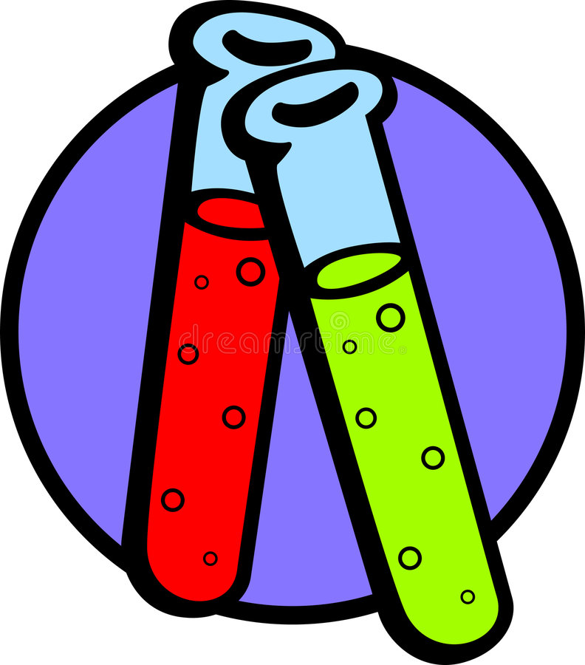

Some Year 8 students want to investigate chemical and physical changes. They decided to combine two unknown clear liquids together in a test tube. A yellow powder forms at the bottom of a test tube floating in a clear liquid.
Explain whether this is a chemical or physical change and give three reasons to support your choice

Chemical change (1)
Any 3 reasonable reasons
Colour change
Irreversible
Solid formed
New substance formed

END OF TEST

